**Prediction of Falcon 9 first stage successful landing**

**(Cover Page)**

**12/12/23**

**Victoria**

**Table of Contents (Section, Subsections of report)**

Executive Summary

Introduction

Methodology

Results

Discussion

Conclusion

Appendix (didn’t fit in main body of report but still important enough to add in)(Resources, acknowledgements, etc.)

(Executive Summary)

Space Y Falcon 9 is predicted to have a high success rate for its first stage landing. As you can see from the below charts the success rate per class has been increasing as time progresses. This is because space Y has been able to learn from their past failures and increase their precision. From the first successful landing on 12/22/2015 until now the successful landings have exponentially increased. The second chart shows that there have been more successful mission outcomes then unsuccessful mission outcomes. These numbers play a role in predicting the success rate for Falcon 9 first stage landing.

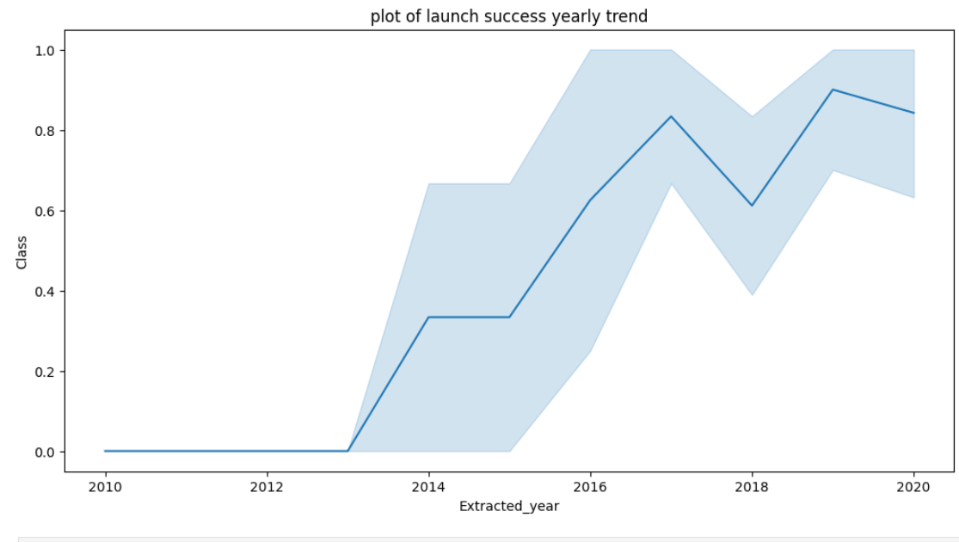

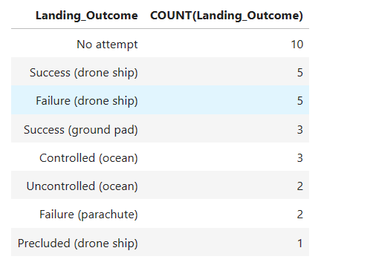

(Introduction)

(States question for Analysis)

This report will provide information on predicting that Falcon 9 first stage will land successfully. To get to this conclusion it took extensive research, data cleansing, and data analysis. The first part of determining this information was to pull specific information from 'https://cf-courses-data.s3.us.cloud-object-storage.appdomain.cloud/IBM-DS0321EN-SkillsNetwork/datasets/API_call_spacex_api.json'. Then the unnecessary and missing information was removed to be able to work with the data that was pertinent to finding the business question. The problem that this answering is if Space Y can be competitive and at a reasonable price to keep in business. Below are some of the flights that were conducted. Some of the flights were successful and some of them were not successful.

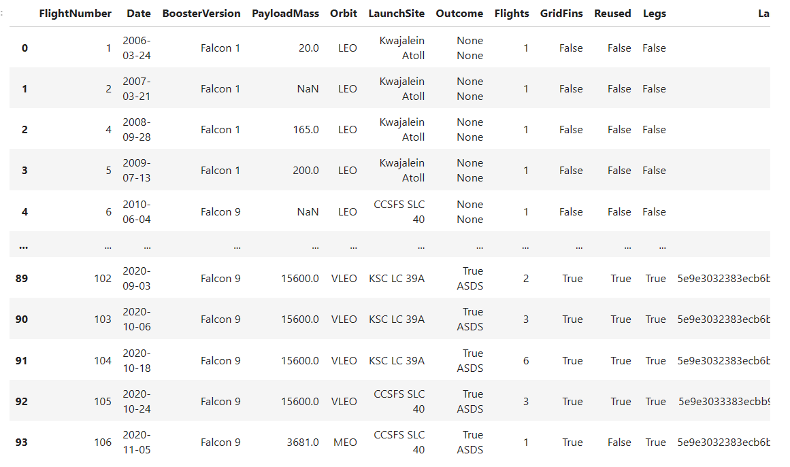

Through this research we have found the below information which tells us that there is a total of 90 launches. The most launches happened at CCAFS SLC 40. Most of the launches went to GTO and ISS. However, GTO was more frequently visited then ISS.

1. True Ocean means the mission outcome was successfully landed to a specific region of the ocean while
2. False Ocean means the mission outcome was unsuccessfully landed to a specific region of the ocean.
3. True RTLS means the mission outcome was successfully landed to a ground pad
4. False RTLS means the mission outcome was unsuccessfully landed to a ground pad.
5. True ASDS means the mission outcome was successfully landed to a drone ship
6. False ASDS means the mission outcome was unsuccessfully landed to a drone ship.
7. None ASDS and None None these represent a failure to land.

Number of launches at each site:

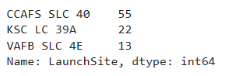

Number of Occurrences at each Orbit :

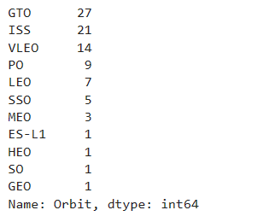

Landing Outcomes:

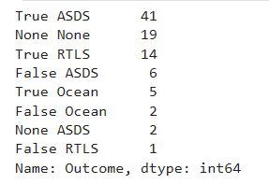

To dig in deeper you can see the landing outcomes for the Failure (drone ship) and Successful (ground pad) between 06-04-2010 and 03-20-2017. There are clearly more successful landings then unsuccessful landings. You will also be able to see the correlation between the flight numbers and launch sites on the scatter plot.

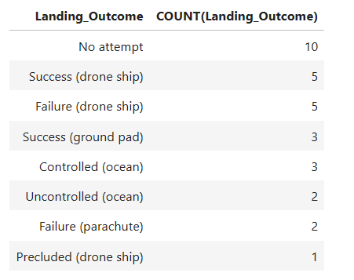

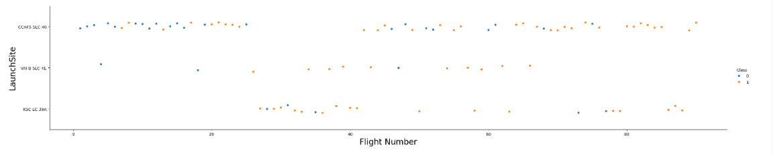

The graphs below show the orbit rate compared to the class. As you can see ES-L1 has the highest and SO has the lowest(none) orbit category. As the years go on the launches keep getting more successful. The company is able to learn from it’s failures and capitalize on it’s successes.

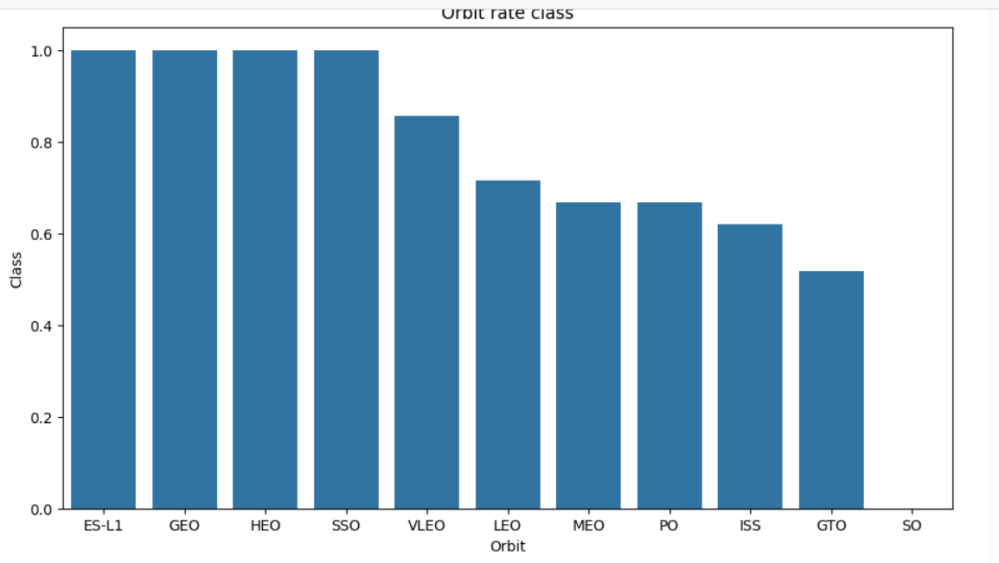

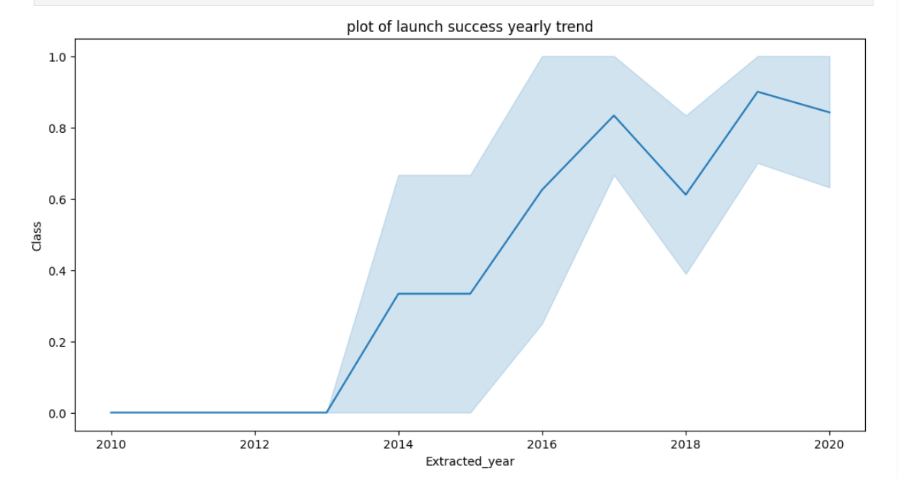

The launch sites for these launches are as follows:

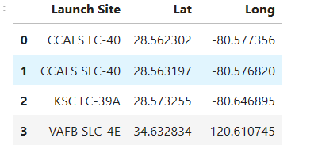

In conclusion, there is a high probability that the launch will be successful. To make Space Y Falcon 9 final prediction there were 72 training sets and 18 test sets with a random variation of 2. The accuracy for the test data was 84%. With all of this data it is clear to see that it is more likely that the launch will be successful then that it will fail.

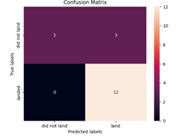

Appendix:

Below are the links where I saved my work incase you want to dive in for further analysis:

**GitHub:** [Tdavis2-2/Falcon-9-Capstone (github.com)](https://github.com/Tdavis2-2/Falcon-9-Capstone/tree/main)

# Data Collection: [Falcon-9-Capstone/Data Collection(1).ipynb at main · Tdavis2-2/Falcon-9-Capstone (github.com)](https://github.com/Tdavis2-2/Falcon-9-Capstone/blob/main/Data%20Collection(1).ipynb)

Date Wrangling: [Falcon-9-Capstone/Data Wrangling.ipynb at main · Tdavis2-2/Falcon-9-Capstone (github.com)](https://github.com/Tdavis2-2/Falcon-9-Capstone/blob/main/Data%20Wrangling.ipynb)

Interactive: [Falcon-9-Capstone/Interactive.ipynb at main · Tdavis2-2/Falcon-9-Capstone (github.com)](https://github.com/Tdavis2-2/Falcon-9-Capstone/blob/main/Interactive.ipynb)

Machine Learning: [Falcon-9-Capstone/ML.ipynb at main · Tdavis2-2/Falcon-9-Capstone (github.com)](https://github.com/Tdavis2-2/Falcon-9-Capstone/blob/main/ML.ipynb)

SQL: [Falcon-9-Capstone/SQL.ipynb at main · Tdavis2-2/Falcon-9-Capstone (github.com)](https://github.com/Tdavis2-2/Falcon-9-Capstone/blob/main/SQL.ipynb)

Visual: [Falcon-9-Capstone/Visual.ipynb at main · Tdavis2-2/Falcon-9-Capstone (github.com)](https://github.com/Tdavis2-2/Falcon-9-Capstone/blob/main/Visual.ipynb)

Webscrapping: [Falcon-9-Capstone/Webscrapping.ipynb at main · Tdavis2-2/Falcon-9-Capstone (github.com)](https://github.com/Tdavis2-2/Falcon-9-Capstone/blob/main/Webscrapping.ipynb)

Below is the link where I got my data from:

**Data Source:** <https://cf-courses-data.s3.us.cloud-object-storage.appdomain.cloud/IBM-DS0321EN-SkillsNetwork/datasets/API_call_spacex_api.json>